What is JDBC?
JDBC (Java Database Connectivity) is an API in Java that allows a Java application to connect to a database such as MySQL, execute SQL queries, and retrieve results.
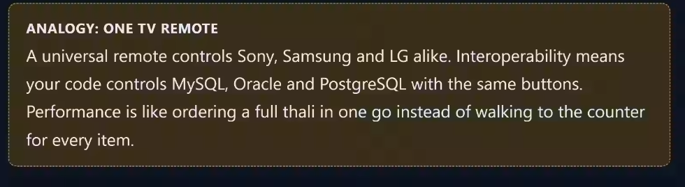
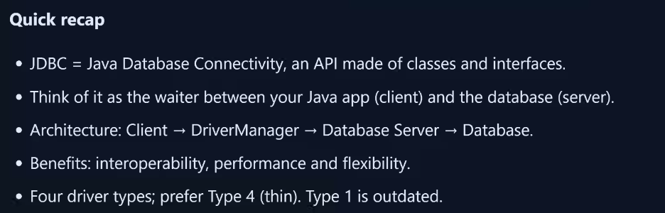
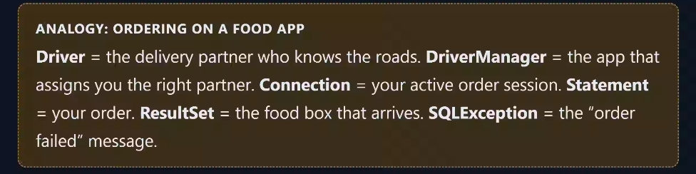
JDBC ->ODBC->SQL
Network protocol driver
Thin Driver(direct connention)


